Numerical Simulation and Performance Analysis of Microwave Transmission Lines and Two-Port Networks Using Scattering Parameters
Aim:
To simulate microwave transmission lines and two-port networks and analyze their performance using scattering parameters (S-parameters).
Procedure:
- Open MATLAB or suitable microwave simulation software.
- Define the transmission line parameters, operating frequency, characteristic impedance, and load impedance.
- Calculate the S-parameters (S11, S21, S12, and S22) for the two-port network.
- Simulate and plot the S-parameters over the selected frequency range.
- Analyze the reflection, transmission, return loss, and insertion loss to evaluate the network performance.
Code:
clc;
clear;
close all;
%% =========================================================
% NUMERICAL SIMULATION OF MICROWAVE TRANSMISSION LINE
% USING SCATTERING PARAMETERS
% ==========================================================
%% INPUT PARAMETERS
c = 3e8; % Speed of light (m/s)
f0 = 10e9; % Operating frequency = 10 GHz
Z0 = 50; % Reference impedance = 50 ohm
fstart = 8e9; % Start frequency = 8 GHz
fstop = 12e9; % Stop frequency = 12 GHz
L = 50e-3; % Network length = 50 mm
ZL = 50; % Load impedance = 50 ohm
%% Frequency sweep
N = 501;
f = linspace(fstart,fstop,N);
omega = 2*pi*f;
%% =========================================================
% TRANSMISSION LINE PARAMETERS
% ==========================================================
% Lossless transmission line
beta = omega/c;
% Electrical length
theta = beta*L;
%% =========================================================
% INPUT IMPEDANCE
% ==========================================================
% General transmission-line input impedance
Zin = Z0 .* (ZL + 1i*Z0.*tan(theta)) ./ ...
(Z0 + 1i*ZL.*tan(theta));
%% =========================================================
% SCATTERING PARAMETERS
% ==========================================================
% Reflection coefficient at input
S11 = (Zin-Z0)./(Zin+Z0);
% For a reciprocal lossless transmission line
S22 = S11;
% Transmission coefficient
S21 = 2*ZL ./ ...
(ZL + Z0 + (ZL-Z0).*exp(-2i*theta));
% For reciprocal network
S12 = S21;
%% =========================================================
% MAGNITUDE OF S PARAMETERS
% ==========================================================
S11_mag = abs(S11);
S21_mag = abs(S21);
S12_mag = abs(S12);
S22_mag = abs(S22);
%% Convert to dB
S11_dB = 20*log10(max(S11_mag,1e-12));
S21_dB = 20*log10(max(S21_mag,1e-12));
S12_dB = 20*log10(max(S12_mag,1e-12));
S22_dB = 20*log10(max(S22_mag,1e-12));
%% Phase
S11_phase = unwrap(angle(S11))*180/pi;
S21_phase = unwrap(angle(S21))*180/pi;
%% Return Loss
ReturnLoss = -20*log10(max(S11_mag,1e-12));
%% Insertion Loss
InsertionLoss = -20*log10(max(S21_mag,1e-12));
%% =========================================================
% DISPLAY RESULTS AT 10 GHz
% ==========================================================
[~,index] = min(abs(f-f0));
fprintf('\n');
fprintf('====================================================\n');
fprintf(' MICROWAVE TRANSMISSION LINE S-PARAMETER ANALYSIS\n');
fprintf('====================================================\n');
fprintf('\nINPUT PARAMETERS\n');
fprintf('Operating Frequency : %.2f GHz\n',f0/1e9);
fprintf('Reference Impedance : %.2f Ohm\n',Z0);
fprintf('Frequency Range : %.2f - %.2f GHz\n',...
fstart/1e9,fstop/1e9);
fprintf('Network Length : %.2f mm\n',L*1000);
fprintf('Load Impedance : %.2f Ohm\n',ZL);
fprintf('\n----------------------------------------------------\n');
fprintf('RESULTS AT %.2f GHz\n',f0/1e9);
fprintf('----------------------------------------------------\n');
fprintf('S11 Magnitude : %.4f\n',S11_mag(index));
fprintf('S11 (dB) : %.4f dB\n',S11_dB(index));
fprintf('S21 Magnitude : %.4f\n',S21_mag(index));
fprintf('S21 (dB) : %.4f dB\n',S21_dB(index));
fprintf('S12 Magnitude : %.4f\n',S12_mag(index));
fprintf('S12 (dB) : %.4f dB\n',S12_dB(index));
fprintf('S22 Magnitude : %.4f\n',S22_mag(index));
fprintf('S22 (dB) : %.4f dB\n',S22_dB(index));
fprintf('Return Loss : %.4f dB\n',ReturnLoss(index));
fprintf('Insertion Loss : %.4f dB\n',InsertionLoss(index));
fprintf('Phase of S21 : %.2f degrees\n',S21_phase(index));
%% =========================================================
% PLOT 1: S11 AND S21 MAGNITUDE
% ==========================================================

figure;
plot(f/1e9,S11_mag,'LineWidth',2);
hold on;
plot(f/1e9,S21_mag,'LineWidth',2);
grid on;
xlabel('Frequency (GHz)');
ylabel('Magnitude');
title('S-Parameter Magnitude');
legend('|S_{11}|','|S_{21}|','Location','best');
%% =========================================================
% PLOT 2: S PARAMETERS IN dB
% ==========================================================
figure;
plot(f/1e9,S11_dB,'LineWidth',2);
hold on;
plot(f/1e9,S21_dB,'LineWidth',2);
grid on;
xlabel('Frequency (GHz)');
ylabel('Magnitude (dB)');
title('S-Parameters in dB');
legend('S_{11}','S_{21}','Location','best');
%% =========================================================
% PLOT 3: S11 PHASE
% ==========================================================
figure;
plot(f/1e9,S11_phase,'LineWidth',2);
grid on;
xlabel('Frequency (GHz)');
ylabel('Phase (degrees)');
title('S_{11} Phase Response');
%% =========================================================
% PLOT 4: S21 PHASE
% ==========================================================
figure;
plot(f/1e9,S21_phase,'LineWidth',2);
grid on;
xlabel('Frequency (GHz)';
ylabel('Phase (degrees)');
title('S_{21} Phase Response');
%% =========================================================
% PLOT 5: RETURN LOSS
% ==========================================================
figure;
plot(f/1e9,ReturnLoss,'LineWidth',2);
grid on;
xlabel('Frequency (GHz)');
ylabel('Return Loss (dB)')
title('Return Loss vs Frequency');
%% =========================================================
% PLOT 6: INSERTION LOSS
% ==========================================================
figure;
plot(f/1e9,InsertionLoss,'LineWidth',2);
grid on;
Output:
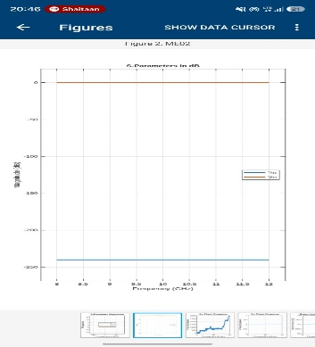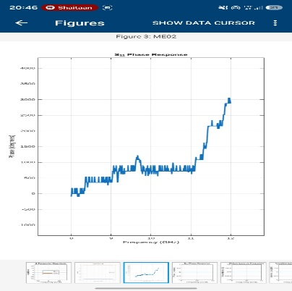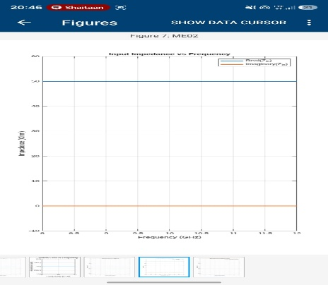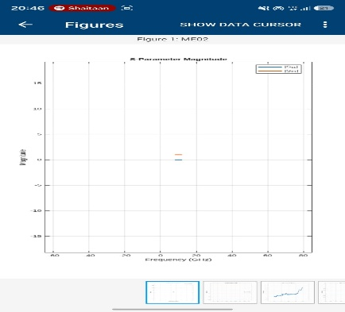

Result:
The microwave transmission lines and two-port networks were simulated successfully. The S-parameters were calculated and analyzed to determine the reflection and transmission characteristics and evaluate the overall performance of the microwave network.

